Information for the proper completion of this report

- TAKE THIS FRONT SHEET to site so you don’t forget taking any photo.
- This document should contain only completion pictures
- Camera picture quality should be set to at least 1280 x 960 (Medium quality)
- Suggestion is never to print this but if it is need printed in low quality, black ink only.
- Save the copy on the server

- To copy a picture in this report → Click once on the existing photo
→ Click on the insert photo icon (Normally located in the lower tool bar)
→ Locate the Photo and insert

- Reduce the document size as follows → Right click on any photo
before saving or printing → Go to format photo
→ Under tab photo, press Compress
→ Apply to all photos in document…OK

01. FRONT site view from a distance of approximately 15M
02. BACK site view from a distance of approximately 15M
03. LEFT site view from a distance of approximately 15M
04. RIGHT site view from a distance of approximately 15M
05. Showing the air condition on the shelter from outside
06. Shelter picture showing the outside in Isometric view
07. Picture of the cable entry from outside the shelter
08. Front picture of the complete closed gate from outside
09. Picture showing the closest 10m of road to the Gate
10. Isometric picture for the generators
11. Picture of the generator and fuel tanks
12. Photo of the DB and AVR from front
13. Close-up of the shelter foundation & footing (1 leg)
14. Close-up of the Tower foundation & footing (1 leg)
15. FRONT Retaining wall taken from outside from the corner
16. BACK Retaining wall taken from outside from the corner
17. LEFT Retaining wall taken from outside from the corner
18. RIGHT Retaining wall taken from outside from the corner
19. Picture of an open manhole
20. Indicating the complete feeder gantry with posts
21. Showing antenna 1 & mount – taken from top of the tower
22. Showing antenna 2 & mount – taken from top of the tower
23. Showing antenna 3 & mount – taken from top of the tower
24. Indicating the complete site from a far distance

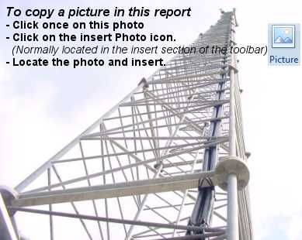
01. FRONT site view from a distance of approximately 15M
02. BACK site view from a distance of approximately 15M
03. LEFT site view from a distance of approximately 15M
04. RIGHT site view from a distance of approximately 15M
05. Showing the air condition on the shelter from outside
06. Shelter picture showing the outside in Isometric view

07. Picture of the cable entry from outside the shelter
08. Front picture of the complete closed gate from outside
09. Picture showing the closest 10m of road to the Gate
10. Isometric picture for the generators
11. Picture of the generator and fuel tanks
12. Photo of the DB and AVR from front

13. Close-up of the shelter foundation & footing (1 leg)
14. Close-up of the Tower foundation & footing (1 leg)
15. FRONT Retaining wall taken from outside from the corner
16. BACK Retaining wall taken from outside from the corner
17. LEFT Retaining wall taken from outside from the corner
18. RIGHT Retaining wall taken from outside from the corner

19. Picture of an open manhole
20. Indicating the complete feeder gantry with posts
21. Showing antenna 1 & mount – taken from top of the tower

22. Showing antenna 2 & mount – taken from top of the tower
23. Showing antenna 3 & mount – taken from top of the tower
24. Indicating the complete site from a far distance

